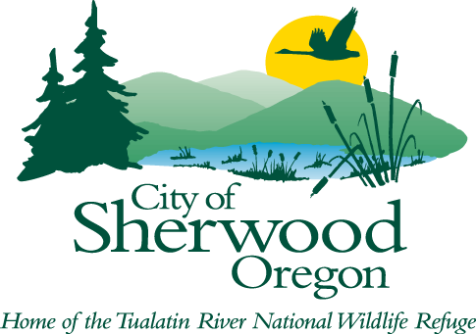

MEETING AGENDA

CULTURAL ARTS COMMISSION

June 15, 2026 at 6:30 pm

SHERWOOD CENTER FOR THE ARTS
22689 SW PINE ST.
SHERWOOD, OR 97140

- CALL TO ORDER

- ROLL CALL

- ADJUSTMENTS TO AGENDA

- CONSENT AGENDA

- Approval of May minutes and June 1 Special Meeting minutes

- CITIZEN COMMENTS

- NEW BUSINESS

- Medallion Art recap
- Cultural festival and engagement plan for 2026-27
- Vinyl wrap progress
- CEP grant process—downtown holiday lighting

- BOARD COMMENTS

- COUNCIL LIAISON REPORT

- CENTER FOR THE ARTS STAFF REPORT

- ADJOURN

How to Provide Citizen Comments:
Citizen comments may be provided in person, in writing, or by telephone. Sign-up forms will be available at the meeting for anyone who wishes to provide comments in person. Written comments must be submitted at least 24 hours in advance of the scheduled meeting start time by email to hallc@sherwoodoregon.gov and must clearly state that it is intended as a general Citizen Comment for this meeting. To provide comment by phone during the live meeting, email or call hallc@sherwoodoregon.gov, 503-625-4261 at least 24 hours in advance of the meeting start time in order to receive dial-in instructions. In-person and telephone comments are limited to 4 minutes per person. Per Council Rules Ch. 2 Section (V)(D)(5), Citizen Comments, “Speakers shall identify themselves by their name and by their city of residence.” Anonymous comments will not be accepted into the meeting record.

ADA Accommodations:
If you require ADA accommodations for this public meeting, please contact hallc@sherwoodoregon.gov or 503-625-4261 at least 48 hours in advance of the scheduled meeting time.

