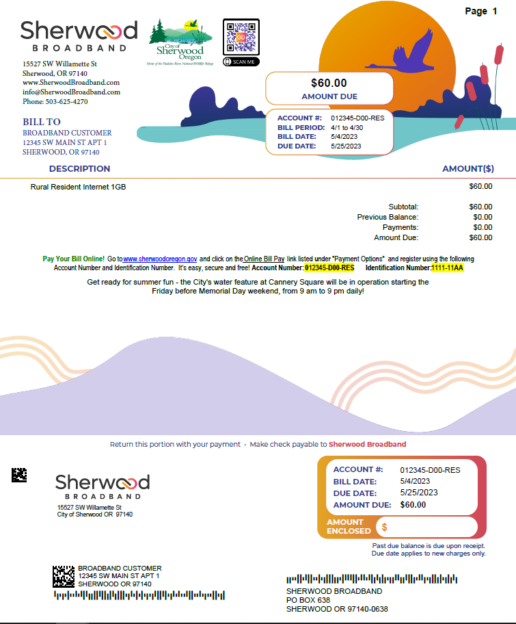

***Look here for bill messages and past due notices.***