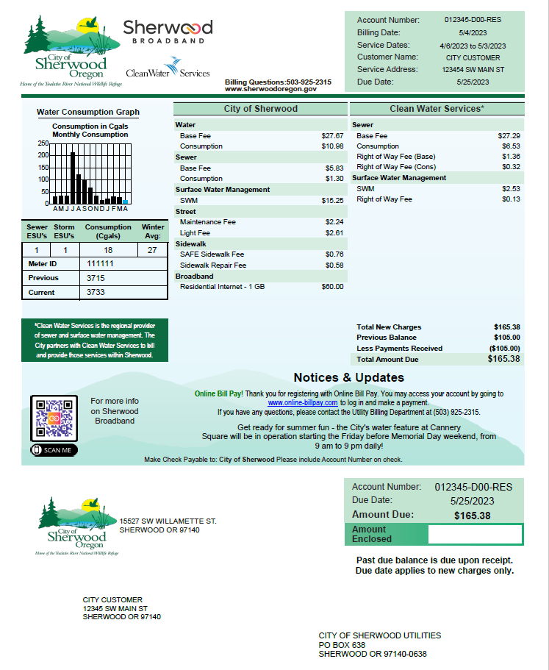

***If you have Broadband service you will find it here.***

***Look here for bill messages and past due notices.***