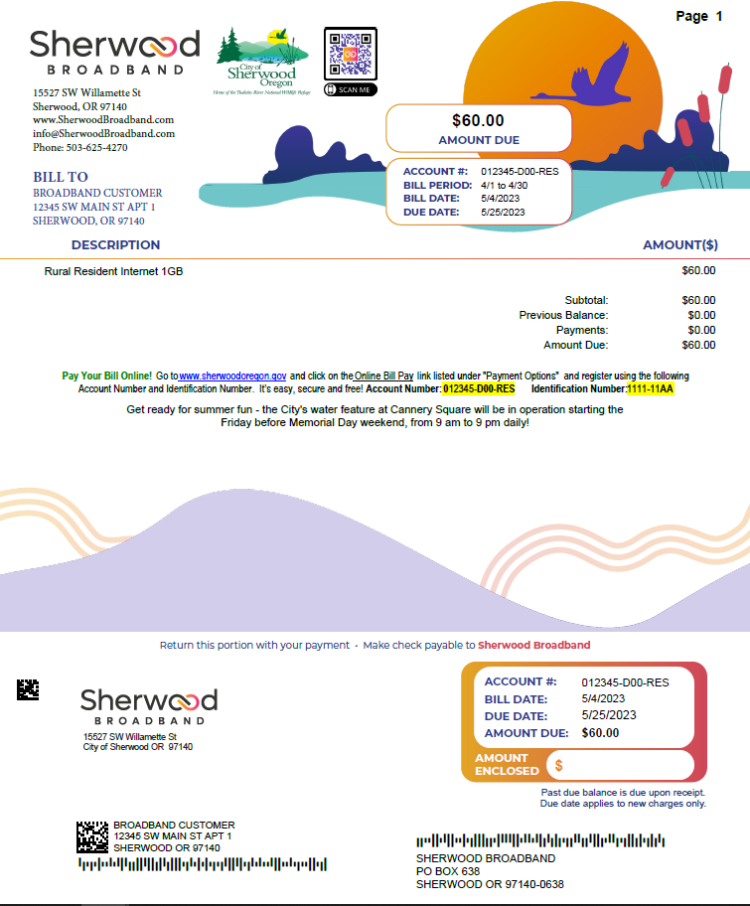

***Look here for Bill messages and past due notices.***